**Report**

**For   
‘Laptop Request Catalog Item’  
Service now project**

**Team ID: NM2025TMID18248**

**TEAM LEADER – YAMINI.S**

**TEAM MEMBERS:**

**VILCY FATHIMA.I**

**YUVASHREE.M**

**SALOMI.S**

**THULASI.D**

Table of Contents

|  |  |  |
| --- | --- | --- |
| S.no | Title | Page.no |
| 1 | Our Problem | 1 |
| 2 | Create Local Update Set | 2 |
| 3 | Create Service Catalog item | 4 |
| 4 | Add Variables | 6 |
| 5 | Create Catalog UI Policies | 12 |
| 6 | Create UI Action | 15 |
| 7 | Exporting Changes To Another Instances | 17 |
| 8 | Retriving The Update Set | 19 |
| 9 | Test Catalog Item | 22 |
| 10 | Conclusion | 25 |

**Our problem**:

In the current organizational setup, employees frequently require laptops to perform their daily work tasks. However, the existing process for requesting laptops is largely manual, which creates several challenges. Manual handling of requests often leads to unnecessary delays, miscommunication, and inefficiencies in the approval and fulfilment cycle. Employees have not standardized, user-friendly platform to submit their requests, and administrators lack a streamlined mechanism to capture, validate, and process the required information. This not only slows down the delivery of essential equipment but also increases the chances of incomplete or inaccurate data being submitted, which further complicates the request handling process. To address these challenges, there is a need for a structured and automated Service catalog item dedicated to laptop requests.

This catalog item should allow employees to easily raise their requests through a simple, intuitive form. Dynamic form behaviour should be introduced to guide users, ensuring that only relevant fields are displayed based on the employee’s input. For example, the form could dynamically adjust to show different options depending on the type of laptop selected or the department the user belongs to. Such functionality would reduce errors, eliminate unnecessary confusion, and improve the overall user experience. In addition, the catalog item should provide clear instructions at every step, making it straightforward even for employees with minimal technical knowledge. To further improve usability, the form should include a reset option that allows users to quickly clear their inputs and start again, if necessary.

This ensures flexibility and reduces the chances of incorrect submissions. On the administrative side, all changes to the form and catalog item must be carefully tracked to maintain proper governance and accountability. Change tracking will also support future audits, version control, and controlled deployments across the organization. By implementing this Service Catalog item, the organization will not only improve efficiency and accuracy in the laptop request process but also establish a scalable, standardized solution that can be extended to other types of requests in the future. This initiative represents a step toward digital transformation, enabling faster service delivery,better governance,andenhanced employee satisfaction.

Update set Create Local Update set:

First open “developer.servicenow.com” and request an instance After creation, click “Start Building” button and open the instance.

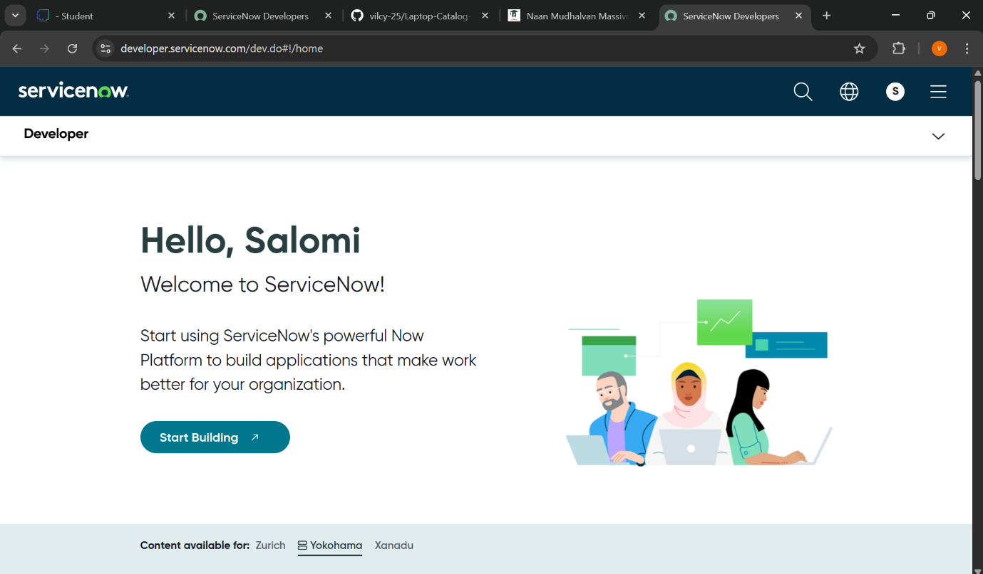

Click on ”All” then search for “Update Sets”.

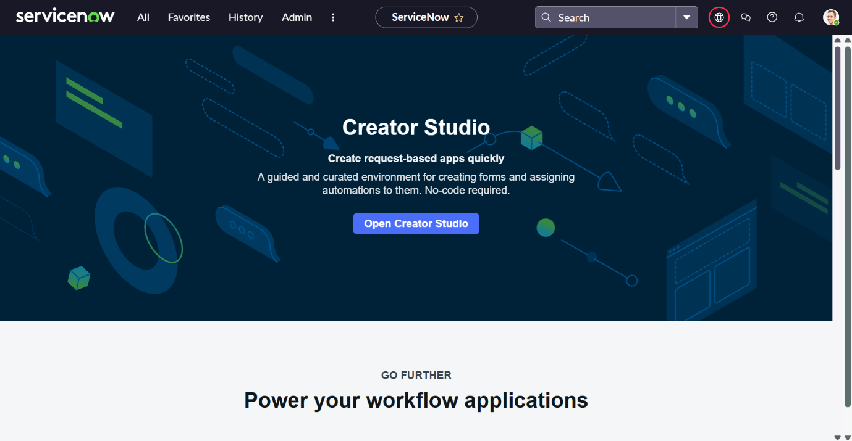

Under System Update Sets, select **Local Update Sets**.

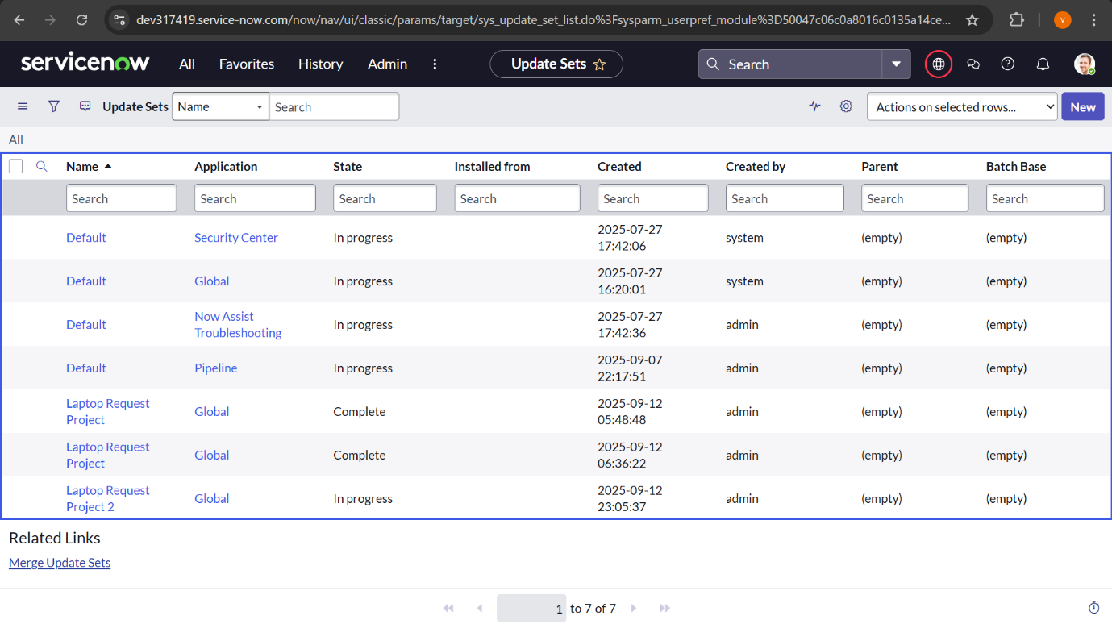

After selecting “**Local Update set**” the above page will open.

In that page click “**New**” in top left corner

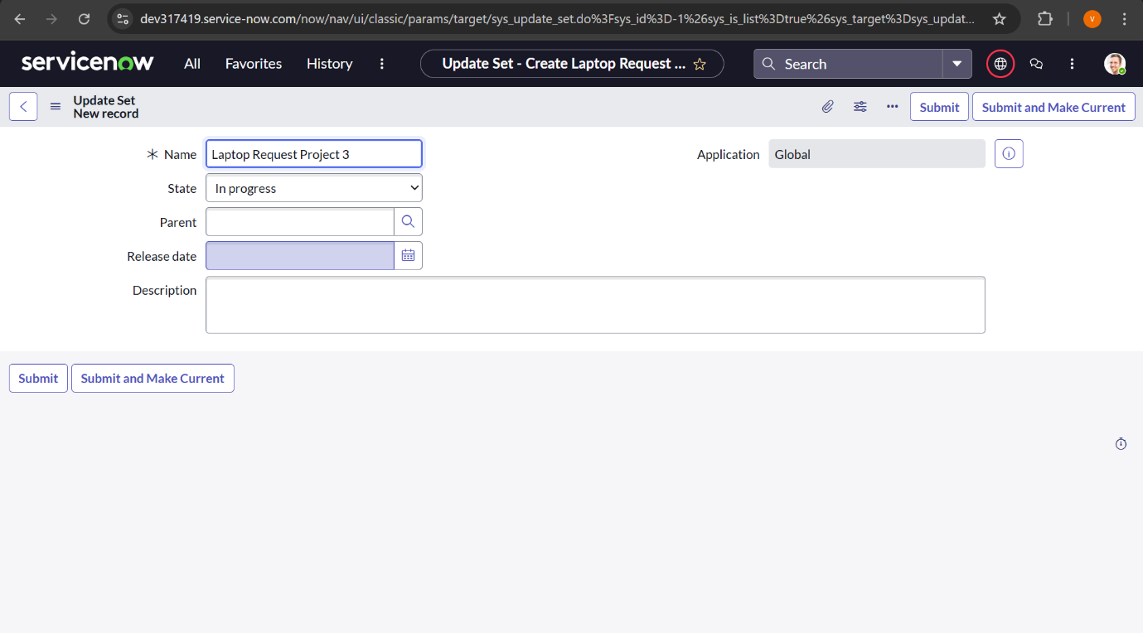

Enter the required details and name the update set **“Laptop Request”**.

Click the **Submit** on right corner and then choose **Make Current**.

**Service Catalog Item**

**Create Service Catalog Item:**

**Click on “All” then search for "service catalog".**

**Under Catalog Definitions, select Maintain Items.**

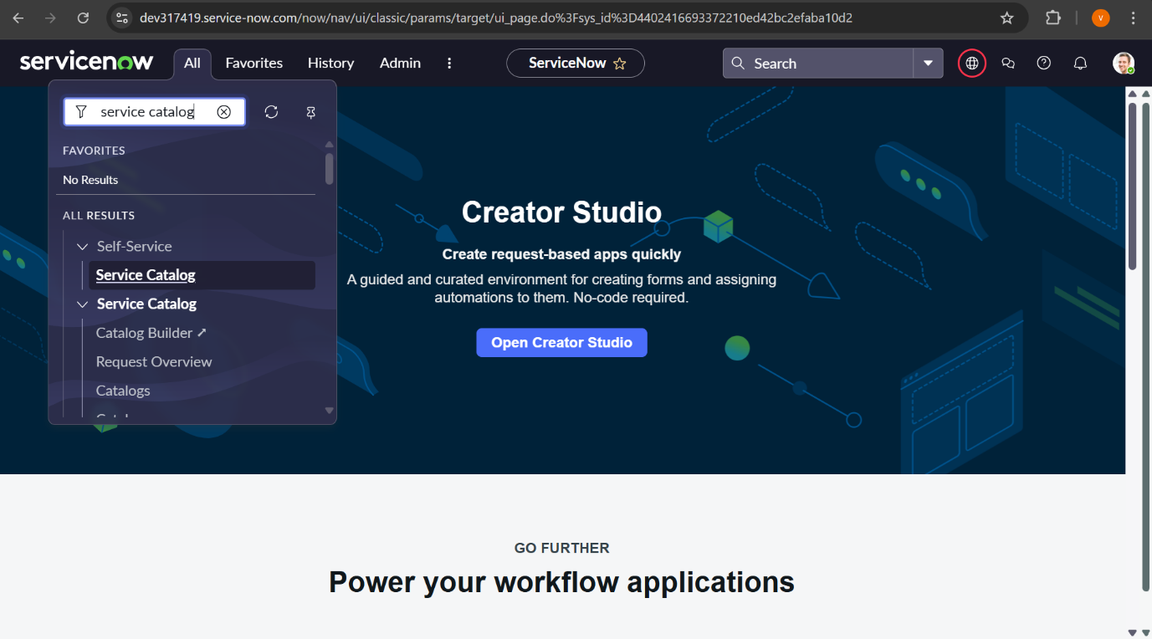

**If you do the above step, the below window will open.**

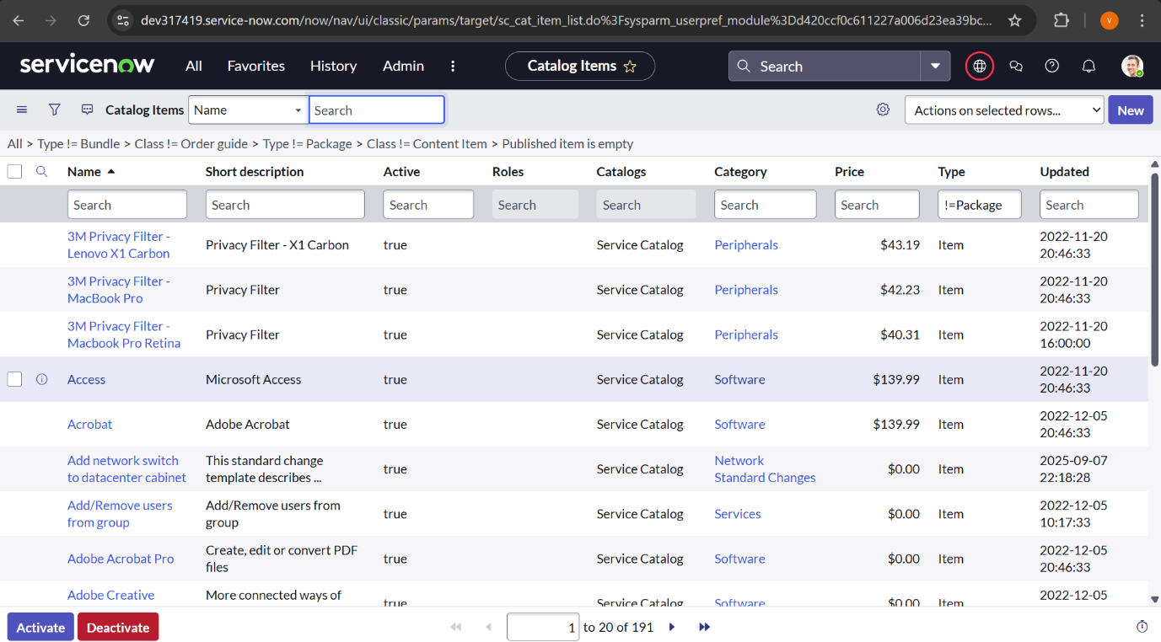

**Click “New” in the top right corner of the opened page**

**If you do that, a new page will open like in the below picture.**

**In that page do the following steps**

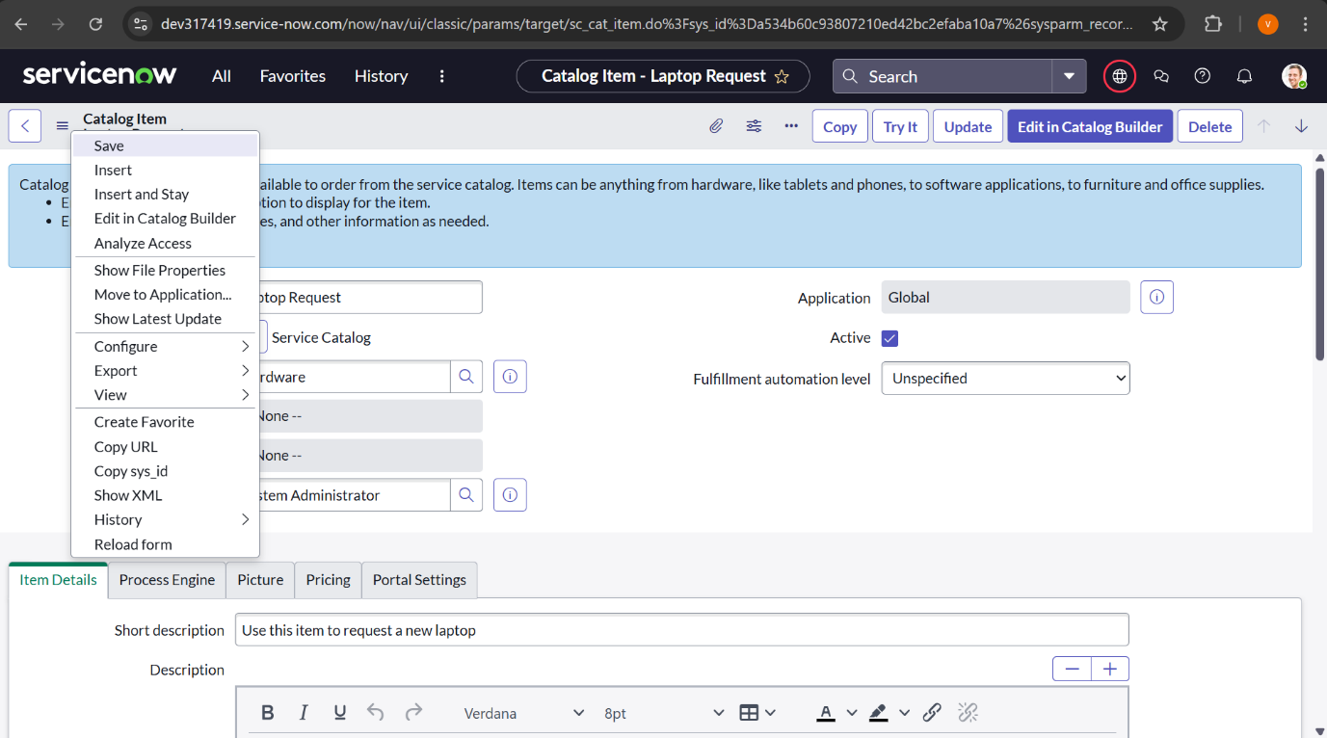

**Enter the following details to create a new catalog item:**

* **Name: Laptop Request**
* **Catalog: Service Catalog**
* **Category: Hardware**
* **Short Description: Use this item to request a new laptop**

**Once all fields are completed, click Save.**

Add variables**:**

**After saving the catalog item form, scroll down to the Variables section in the related list.**

**That will look like the below picture.**

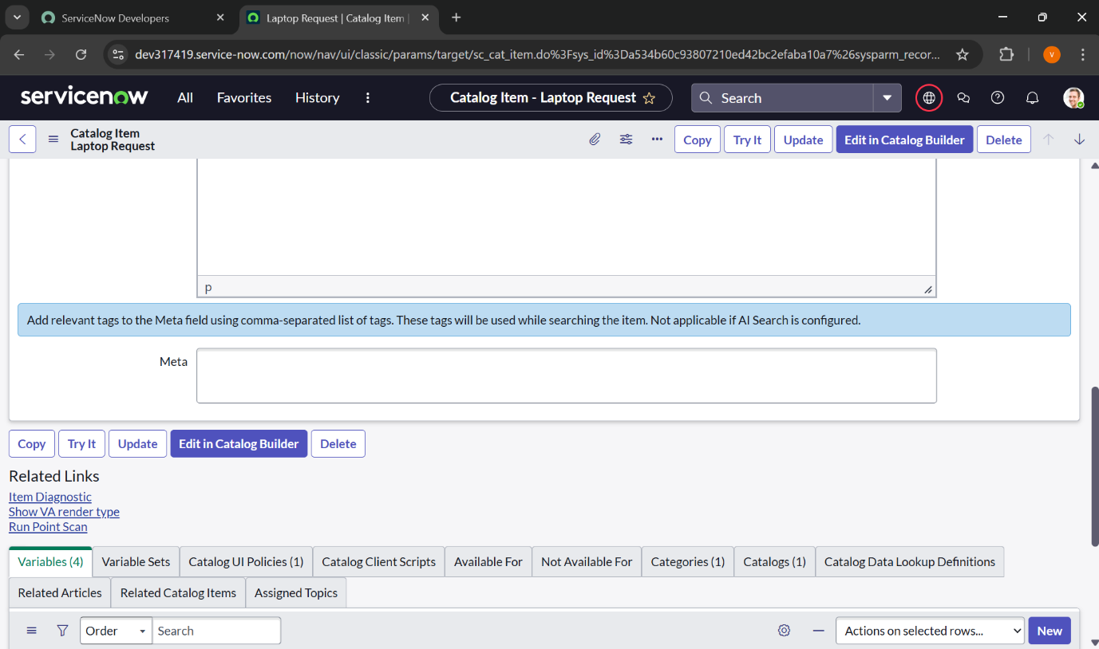

**Click “New” bottom right corner**

**After that below page will open.**

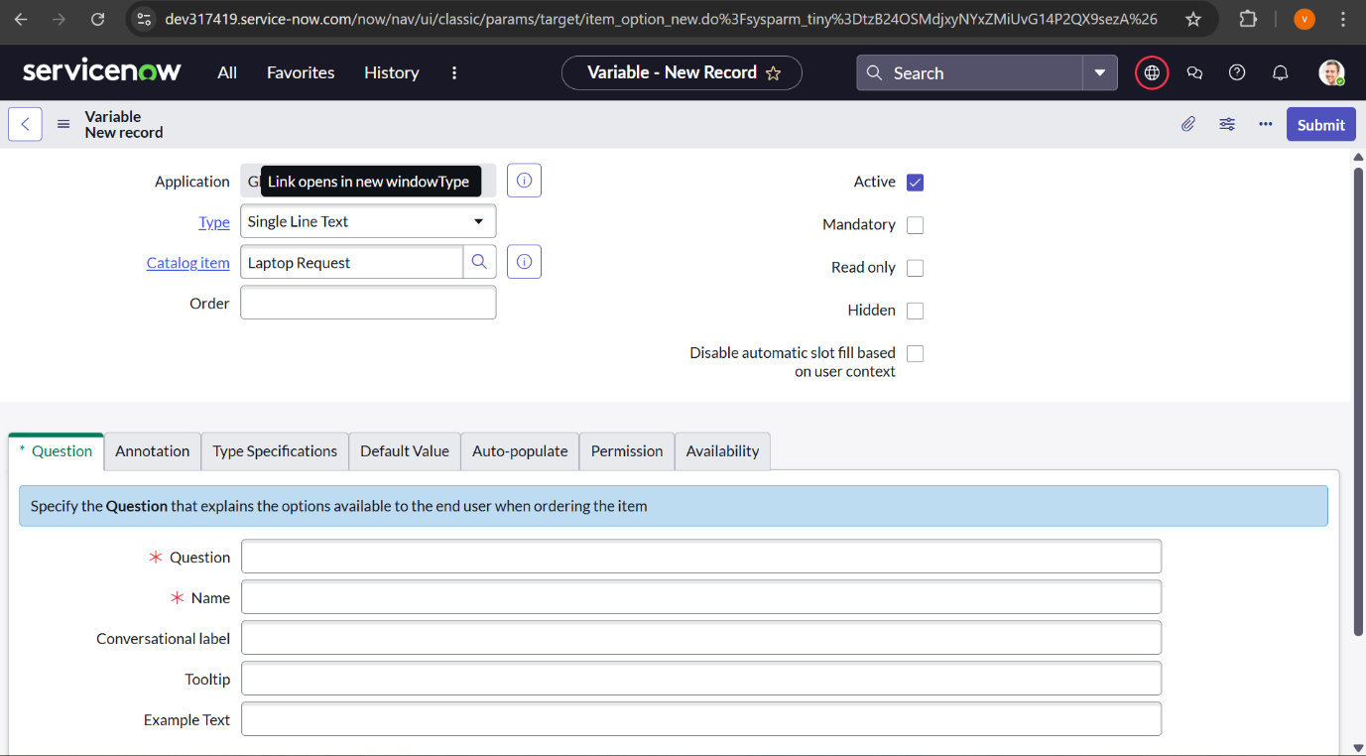

**In that form enter these details:**

* **Question: Laptop Model**
* **Type: Single Line Text**
* **Name: laptop_model**
* **Order: 100**

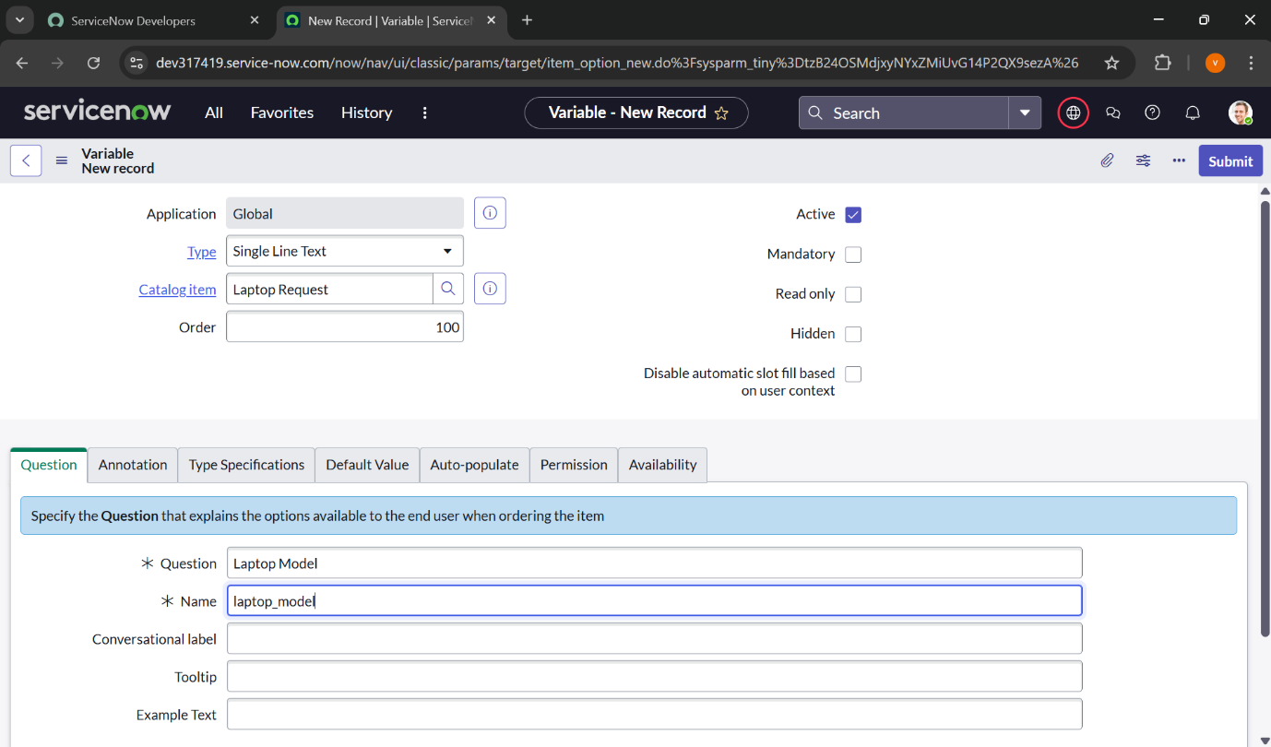

**Click Submit to save the variable.**

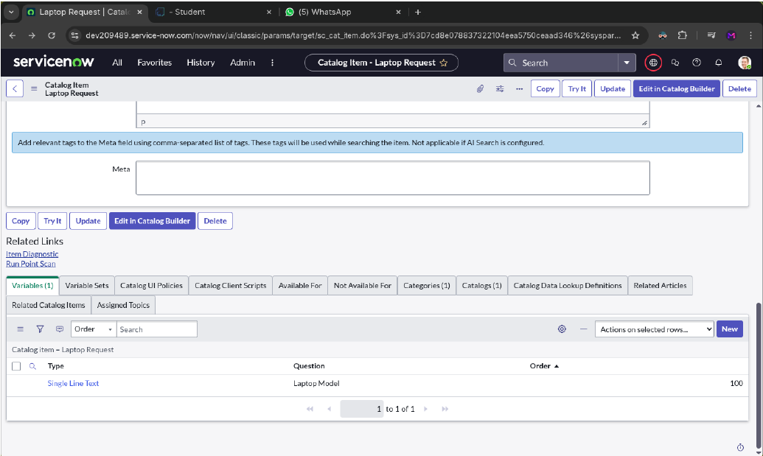

**Click again “New” and add these 2nd details:**

* **Question: Justification**
* **Type: Multi Line Text**
* **Name: justification**
* **Order: 200**

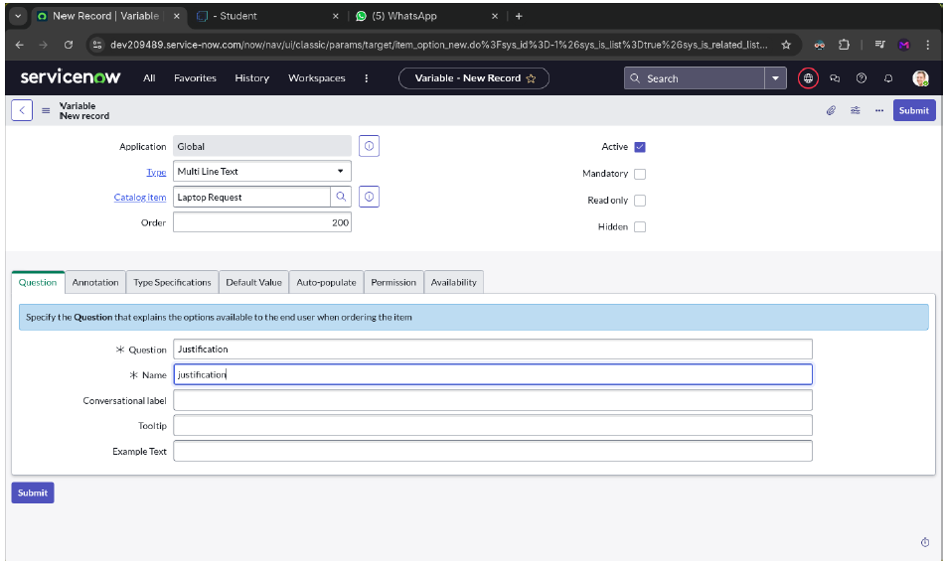

**Click Submit to save the variable.**

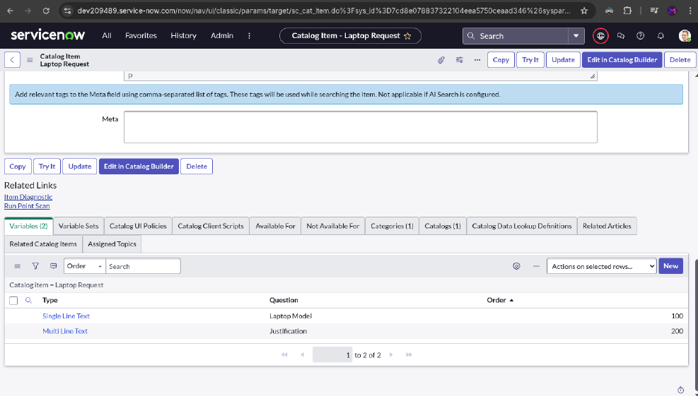

**Click again “New” and add these 3rd details:**

* **Question: Additional Accessories**
* **Type: Checkbox**
* **Name: additional_accessories**
* **Order: 300**

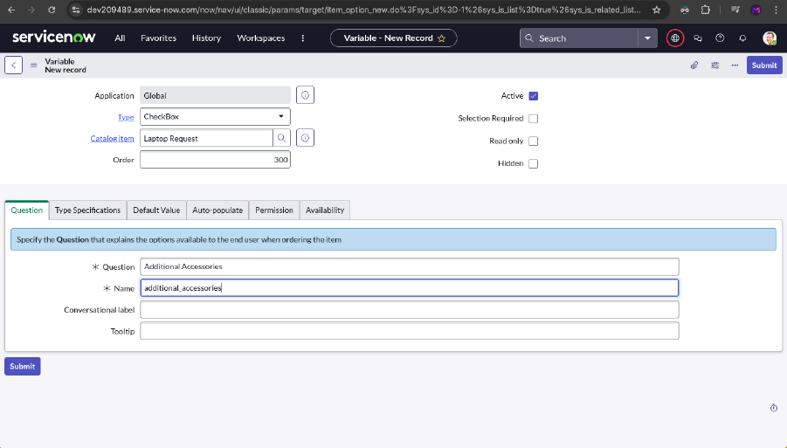

**Click Submit to save the variable**

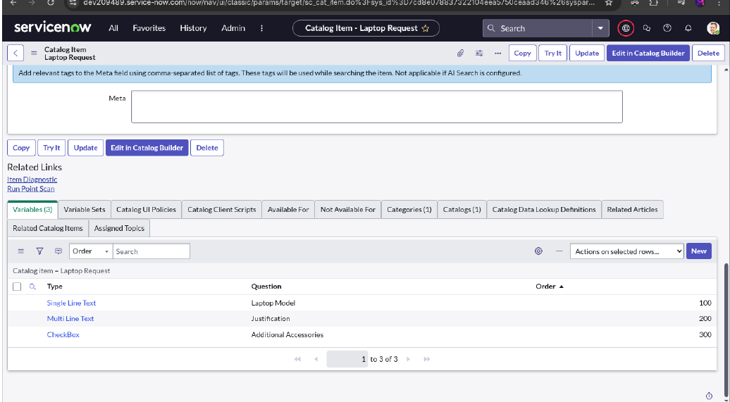

**Click again “New” and add these 4th details:**

* **Question: Accessories Details**
* **Type: Multi Line Text**
* **Name: accessories_details**
* **Order: 400**

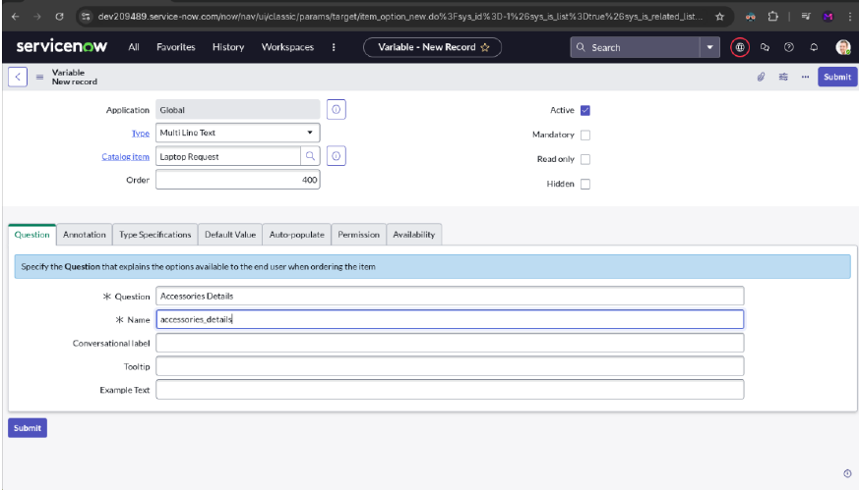

**Click Submit to save the variable**

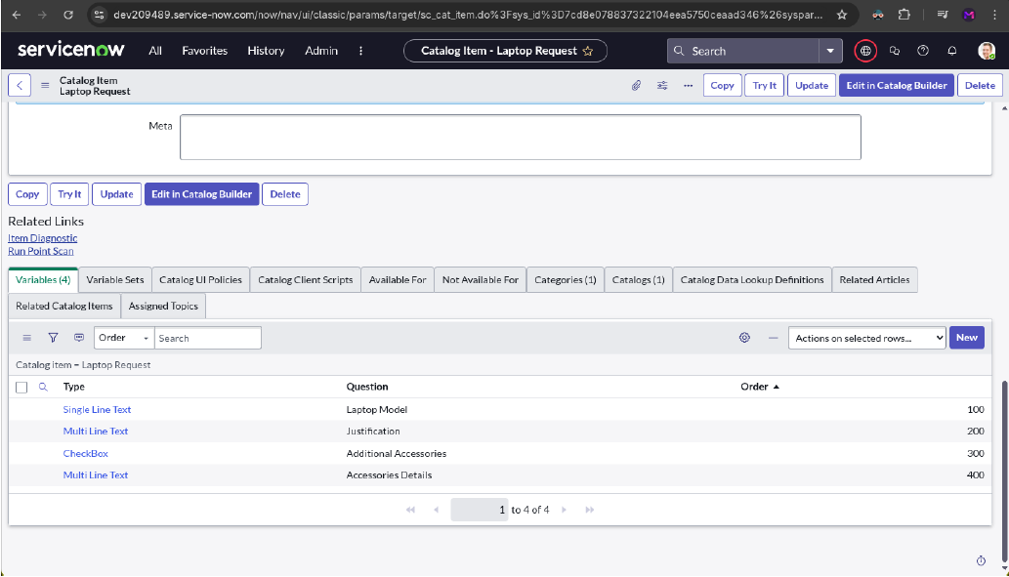

**After adding all of these, make sure to save the form.**

**To view demo of this, click “Try It” of the top right corner.**

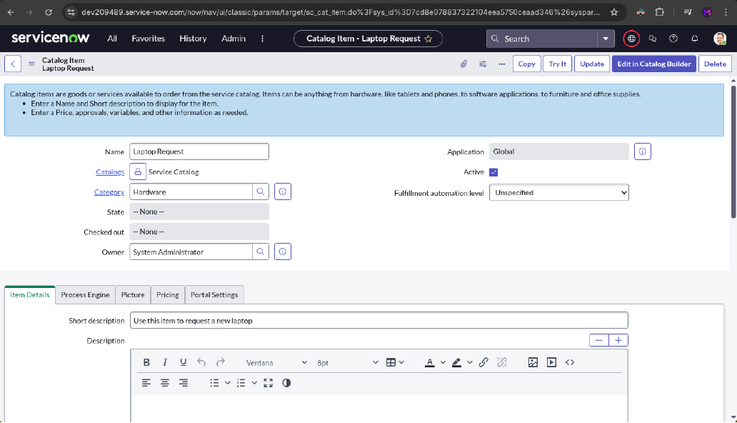

**The demo will look, like this**

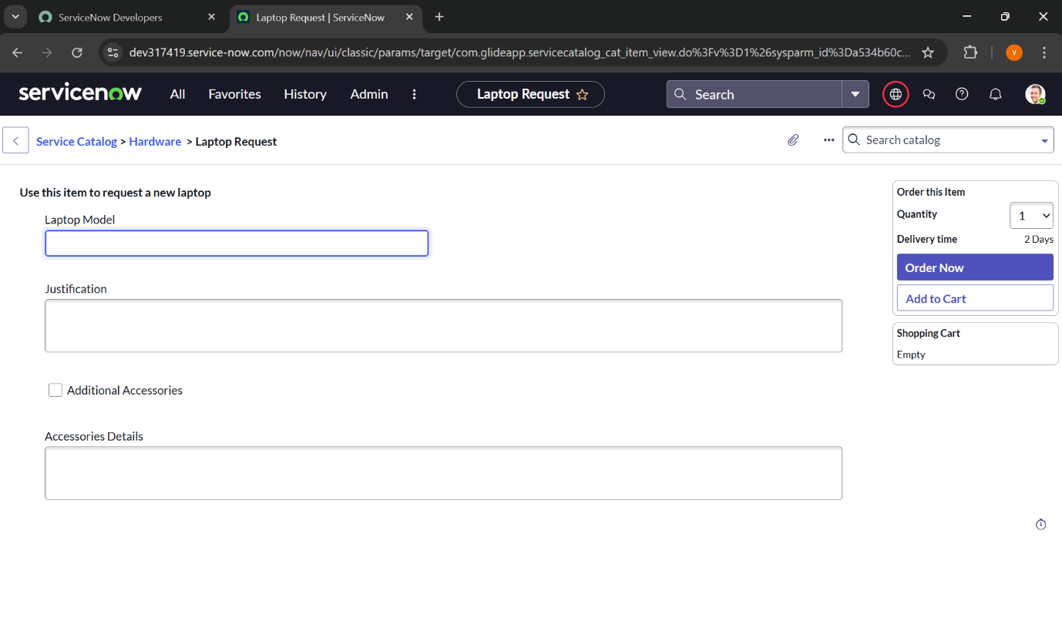

UI Policy

Create Catalog UI policies**:**

**Navigate to All → search for Service Catalog.**

**Under Catalog Definitions, select Maintain Items.**

**Search for the previously created item “Laptop Request”.**

**Open the item, then scroll down to the Catalog UI Policies related list.**

**Click New to create a new UI policy.**

**Enter the following details:**

* **Short Description: Show Accessories Details** 
  1. **Catalog Condition (When to Apply): Field: additional_accessories**
  2. **Operator: is**
  3. **Value: true**
  4. 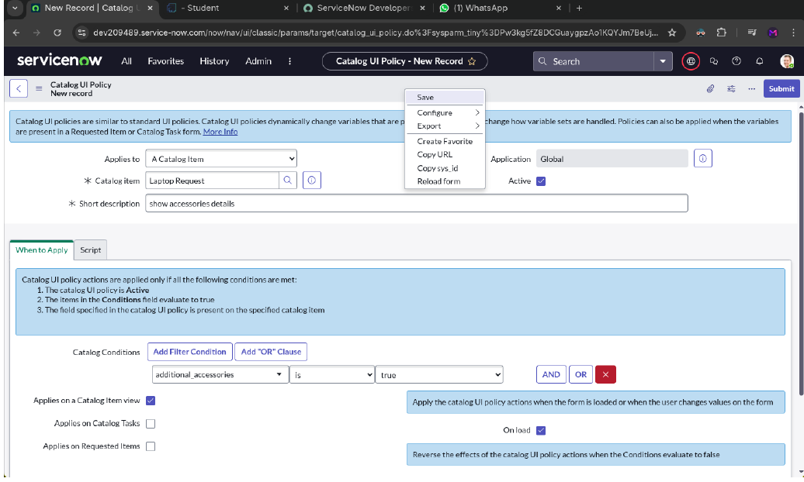

Click **Save** (do not click **Submit**).

Scroll down and open the **Catalog UI Policy Actions** related list.

* 1. Click **New** to create a new action.
  2. 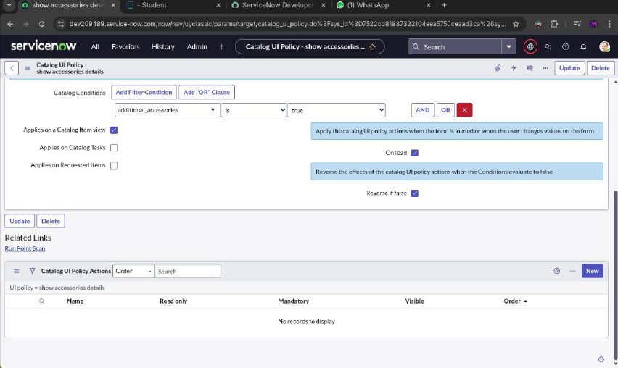

A new page will open and, in that page, do the following

Configure the action with the following details:

* **Variable Name**: accessories_details
* **Order**: 100
* **Mandatory**: True
* **Visible**: True

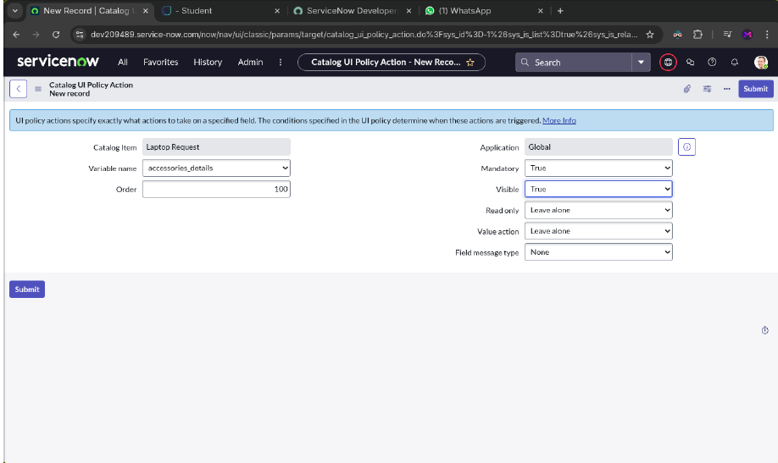

You can see the demo of it

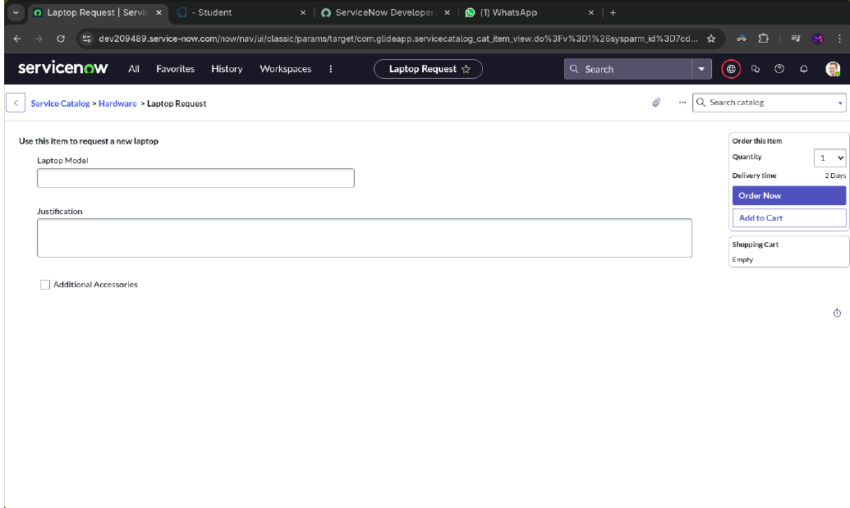

After clicking “**Additional Accessories**” it will look like below image:

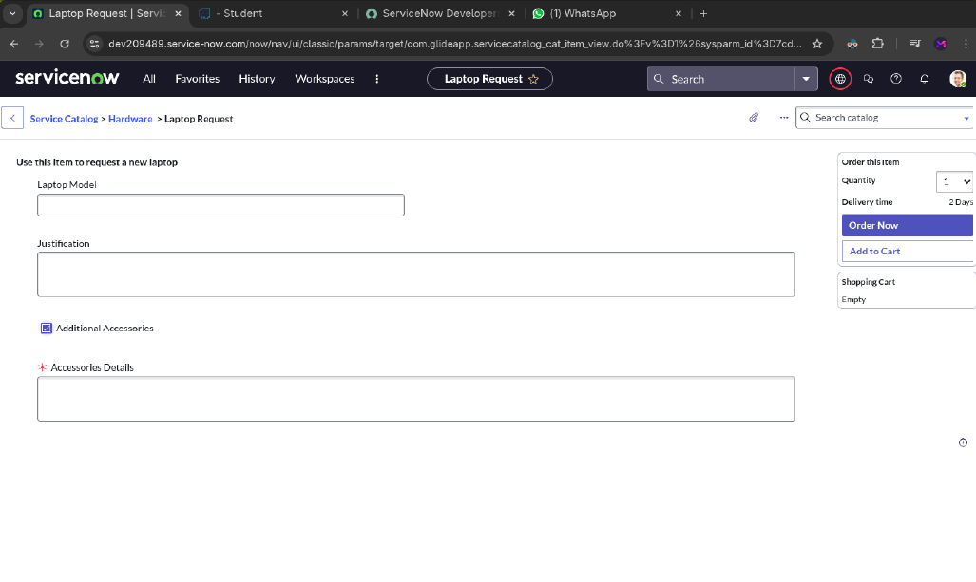

UI Action

**Create UI action:**

Go to **All → search for “UI Actions”**.

Under **System Definition**, select **UI Actions**

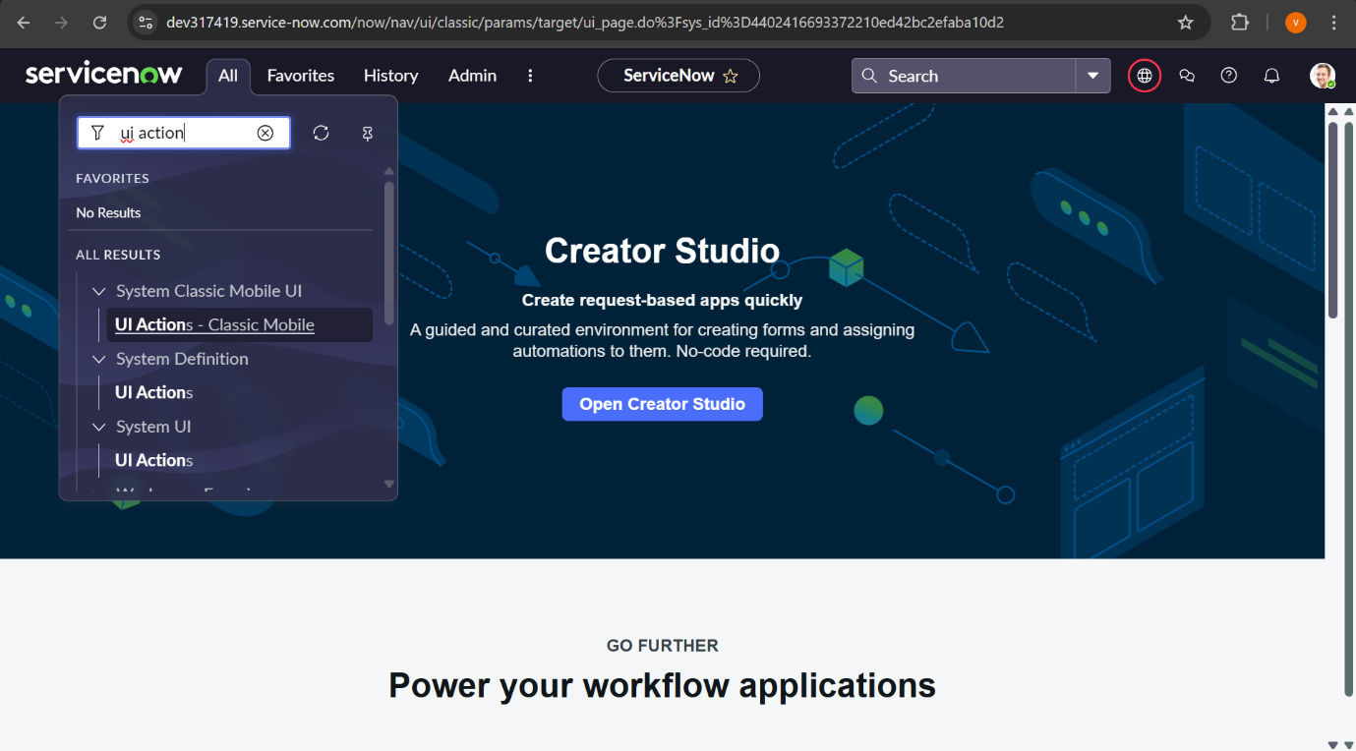

After navigating to that page, it will look like the below image.

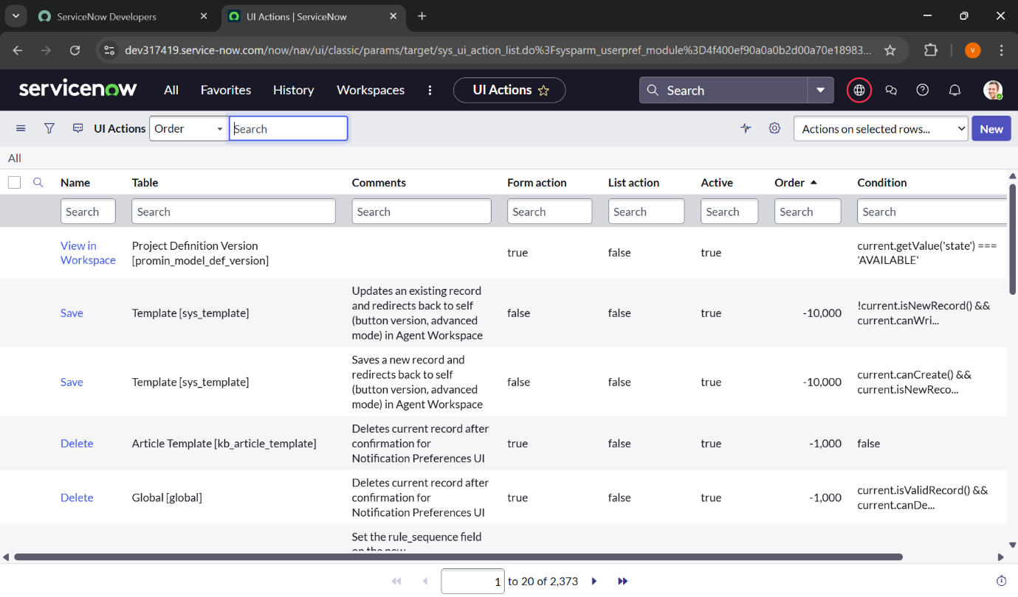

Click **New** to create a new UI Action.

Enter the following details:

* **Table**: Shopping Cart (sc_cart)
* **Order**: 100
* **Action Name**: Reset form
* **Client**: Checked

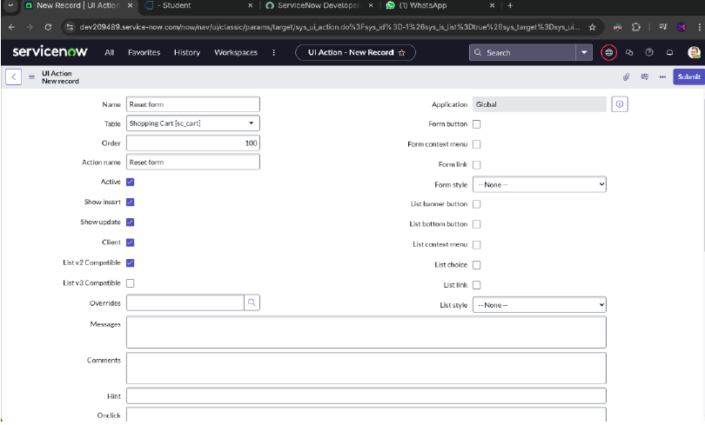

Add the following script and click “**Save**”:

**function resetForm() {**

g_form.clearForm(); // Clears all fields in the form

alert("The form has been reset.");

**}**

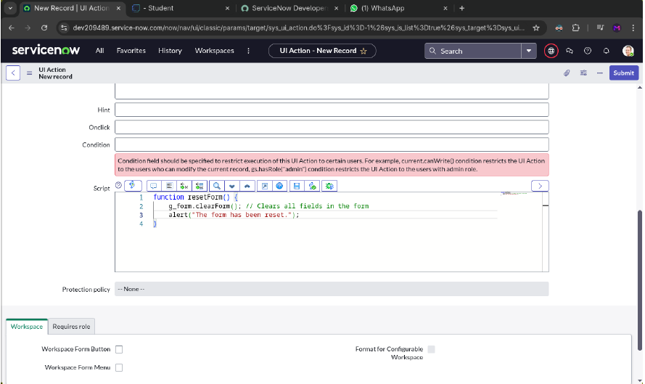

Export Update set

**Exporting changes to another instances:**

Navigate to **All → search for Update Sets** and **select Local Update Sets**

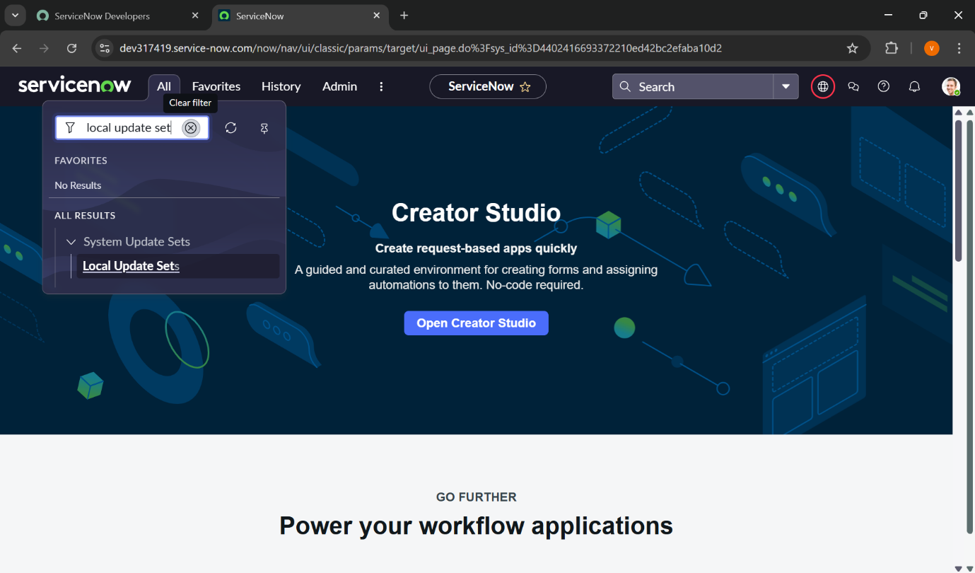

Open the previously created update set **“Laptop Request Project”**.

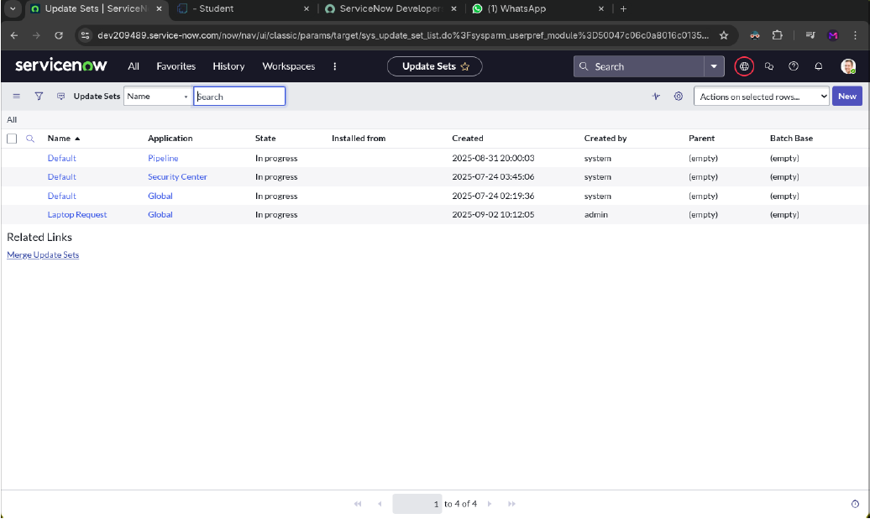

Change the **State** to **Complete**.

In the **Updates** related list, you can view all the changes captured under this update set.

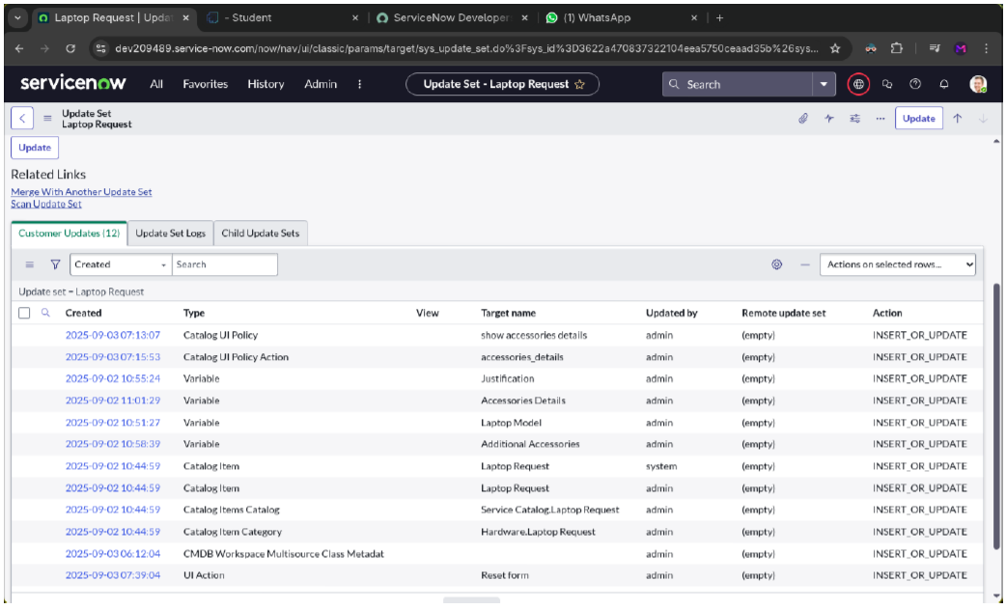

Click **Export to XML** to download the update set as a file.

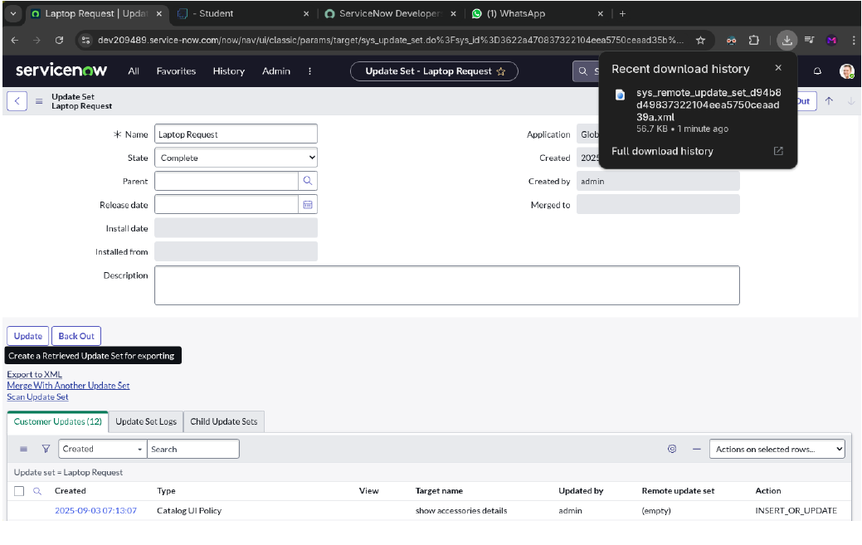

Login to another Instance

Retrieving the update set:

Open another ServiceNow instance with friend’s login

Navigate to **All → search for Update Sets**.

Under **System Update Sets**, select **Retrieved Update Sets**.

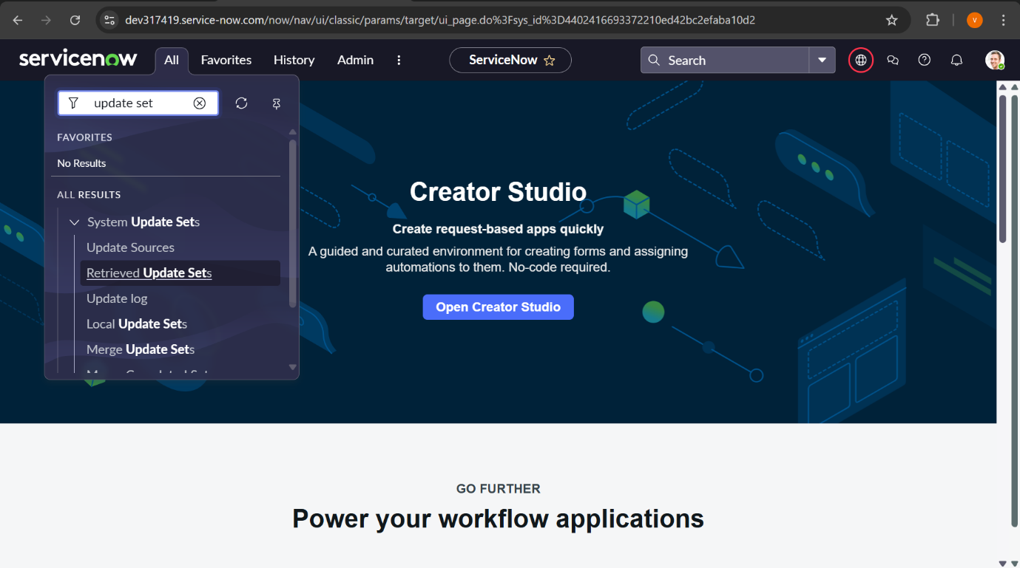

In this page, click “**Import Update Set from XML**” in the bottom left corner

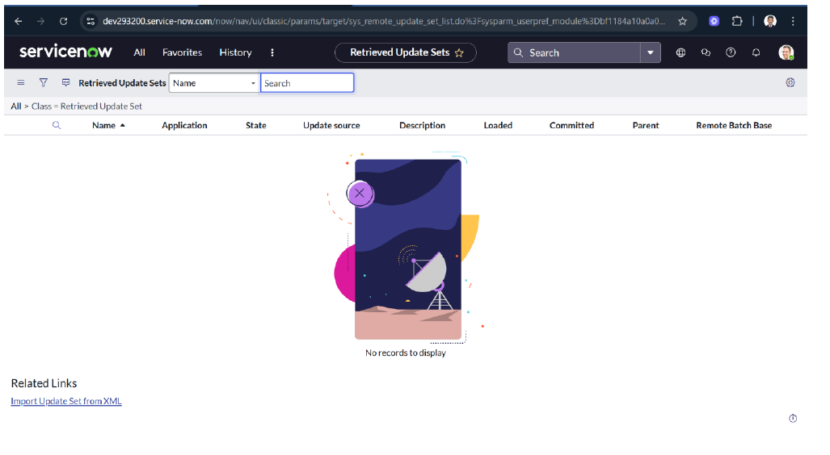

Upload the previously downloaded XML file in this page and click “**Upload**” button

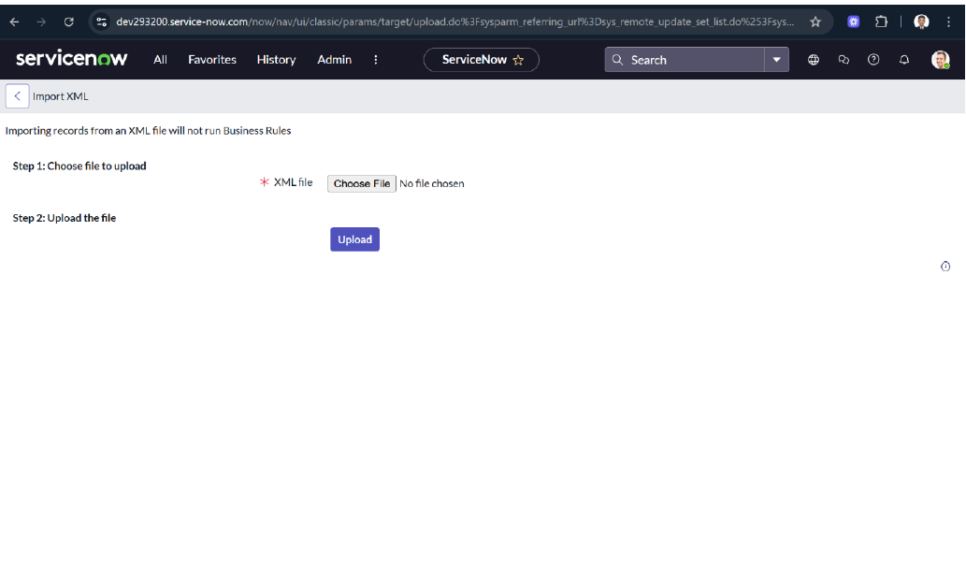

Open the **Retrieved Update Set** named **“Laptop Request Project”**

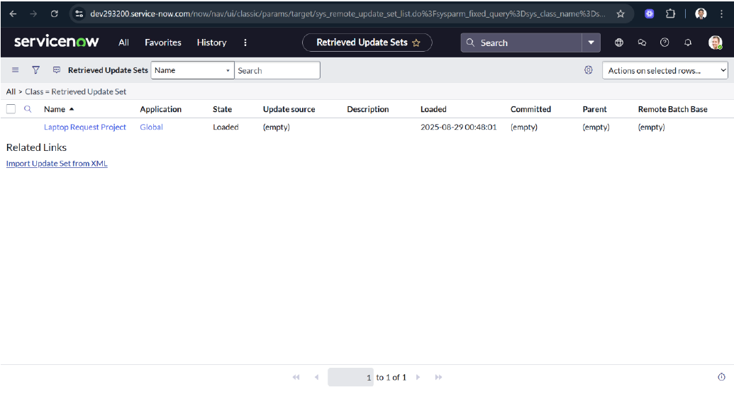

Click **Preview Update Set** to review the changes.

After verifying, click **Commit Update Set** to apply the updates.

You can also review all captured changes in the **Updates** related tab.

Once the update set is committed, all changes from the previous instance will be applied to the current instance.

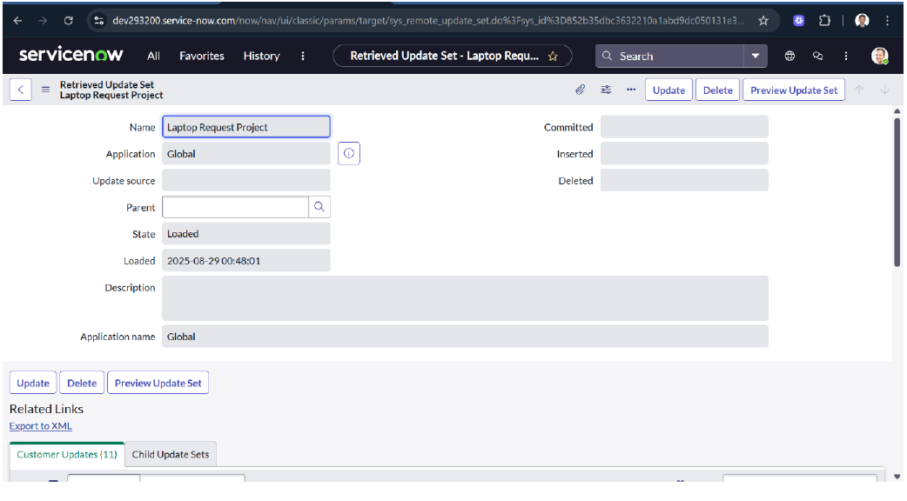

**Testing**

**Test Catalog Item:**

In the target instance, search for **Service Catalog** in the application navigator.

Under **Service Catalog**, select **Catalog**.

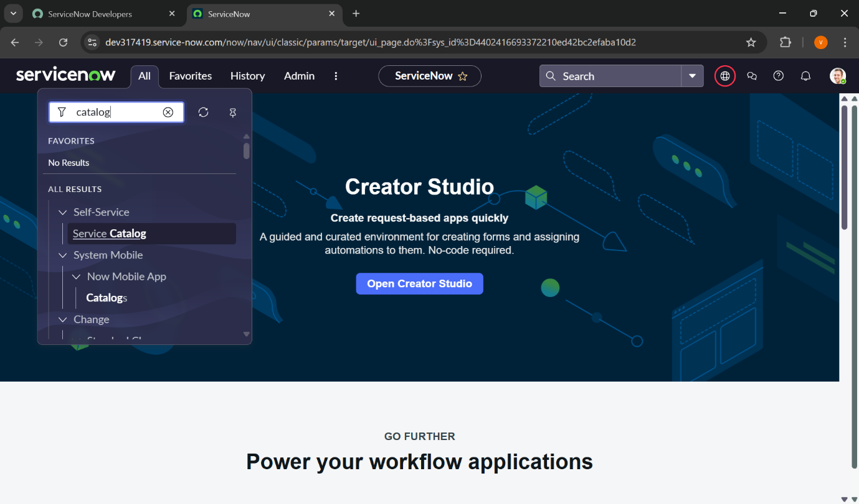

Choose the **Hardware** category.

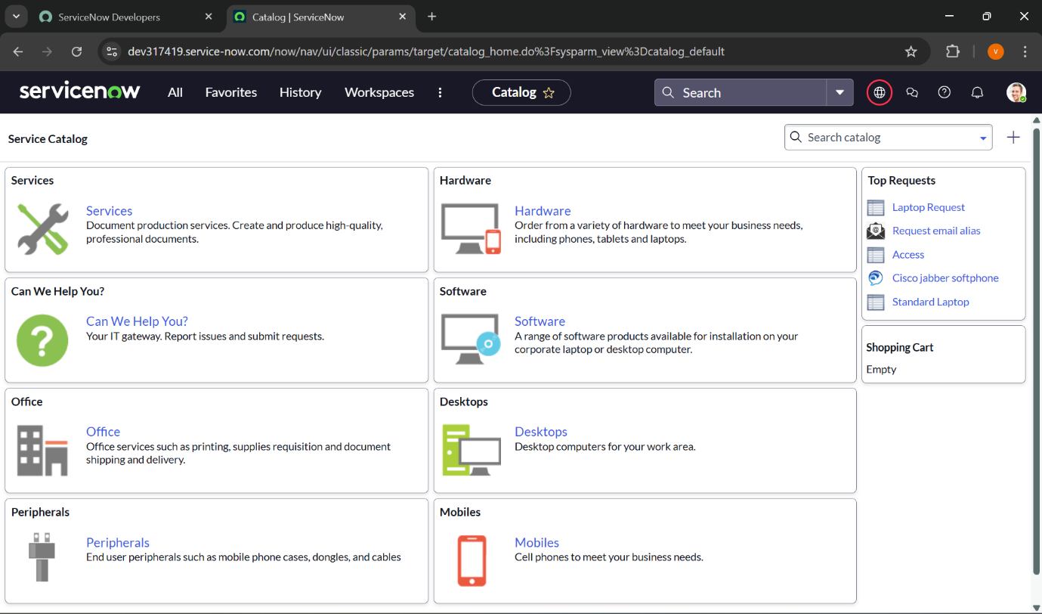

Search for the **“Laptop Request”** item in the **Hardware** category

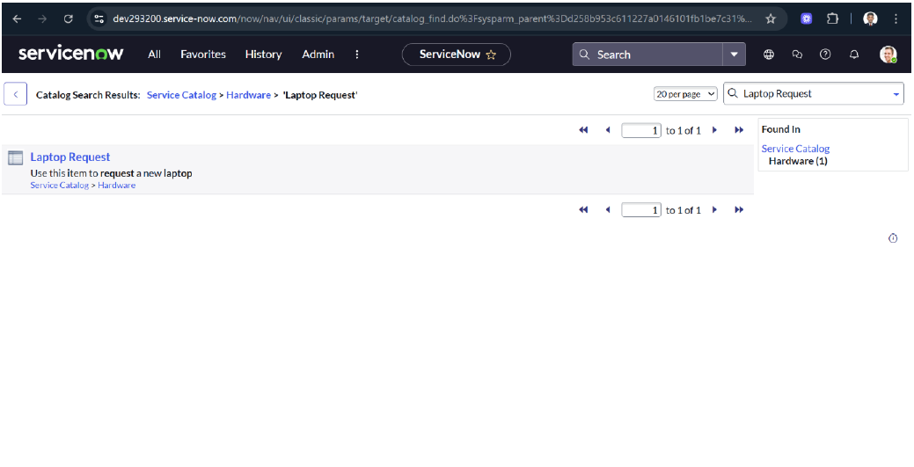

Open the **Laptop Request** catalog item.

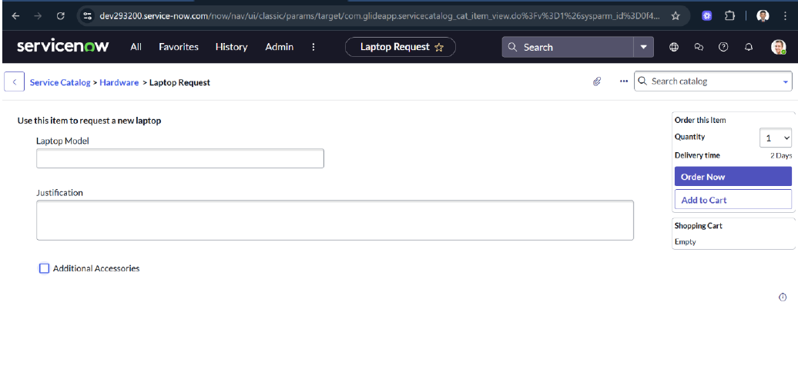

In our scenario, when the **Additional Accessories** checkbox is selected, the **Accessories Details** field becomes visible and is set as mandatory. Upon testing, the functionality works as expected and meets all the specified requirements

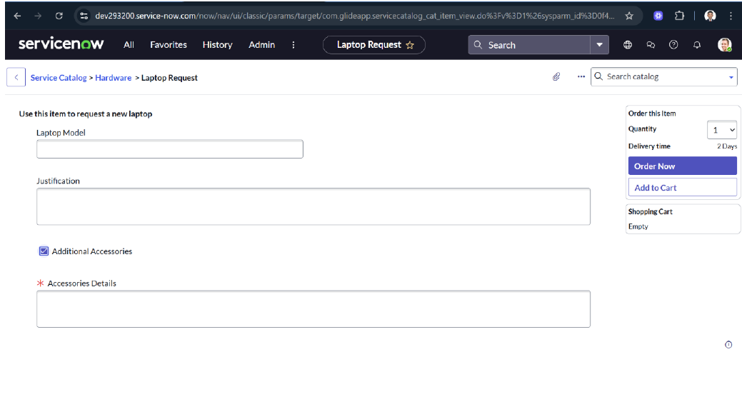

**Conclusion:**

The **Laptop Request Catalog Item** project has been successfully implemented to streamline and automate the process of requesting laptops within the organization. Previously, employees relied on a largely manual system, which was prone to delays, errors, and inconsistencies. Requests were often incomplete or submitted incorrectly, leading to inefficiencies and frustration for both employees and administrators. By leveraging **ServiceNow's Service Catalog capabilities**, this project introduces a structured, automated solution that addresses all these challenges.

The solution provides a dynamic catalog item that is intuitive and user-friendly. Users are guided through the request process with clearly defined fields and instructions, ensuring accurate and complete information is submitted every time. Conditional behaviours, such as making the **Accessories Details** field visible and mandatory only when the **Additional Accessories** checkbox is selected, help reduce confusion and prevent errors. These dynamic features improve usability, making it easier for employees to complete their requests correctly on the first attempt.

From an administrative perspective, the catalog item simplifies the management of laptop requests. All changes and updates are tracked within ServiceNow, providing governance, accountability, and the ability to audit processes if necessary. The use of update sets allows seamless deployment across instances, ensuring consistency and efficiency in implementing changes. Additionally, the reset functionality for the form ensures that users can quickly clear and start over if needed, further enhancing the overall user experience.

By replacing the previous manual workflow with an automated, structured approach, the project has significantly improved service delivery. The new system reduces the time required to process requests, minimizes errors, and ensures that employees receive the equipment they need without unnecessary delays. Moreover, it enhances employee satisfaction by offering a modern, professional, and straightforward request experience that aligns with organizational standards.

Overall, this project demonstrates the power and flexibility of **ServiceNow** in transforming traditional, error-prone processes into efficient, automated, and user-centric workflows. The **Laptop Request Catalog Item** not only meets the organization’s current needs but also provides a scalable solution that can be adapted for other service requests in the future. By combining automation, usability, and governance, the project serves as a strong example of how technology can improve operational efficiency and employee satisfaction simultaneously.